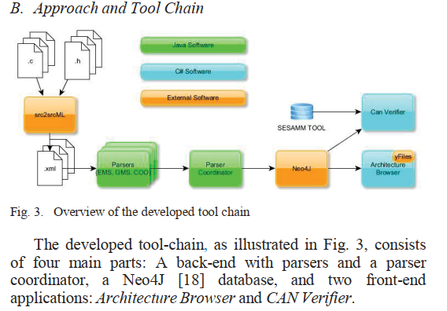

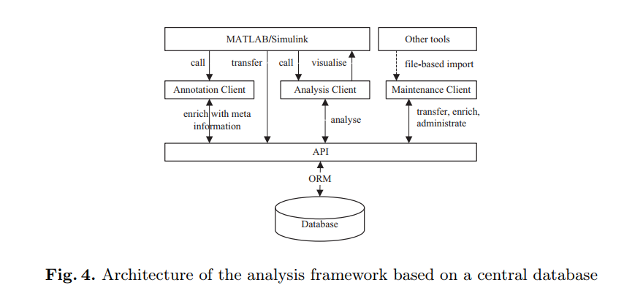

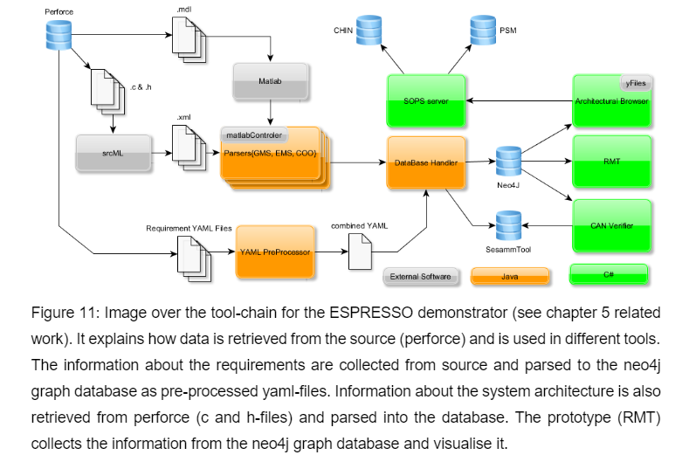

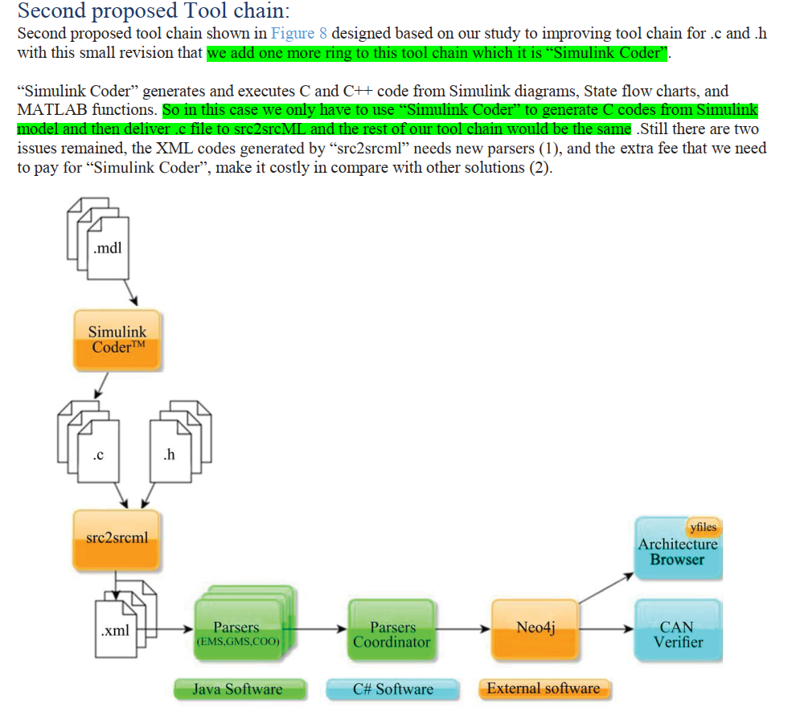

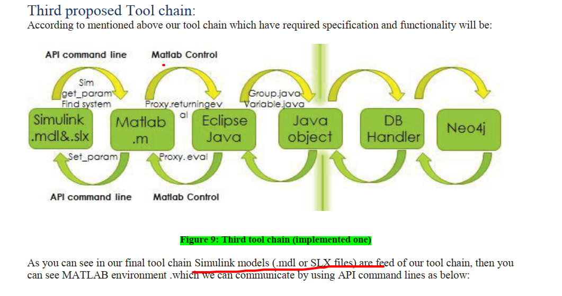

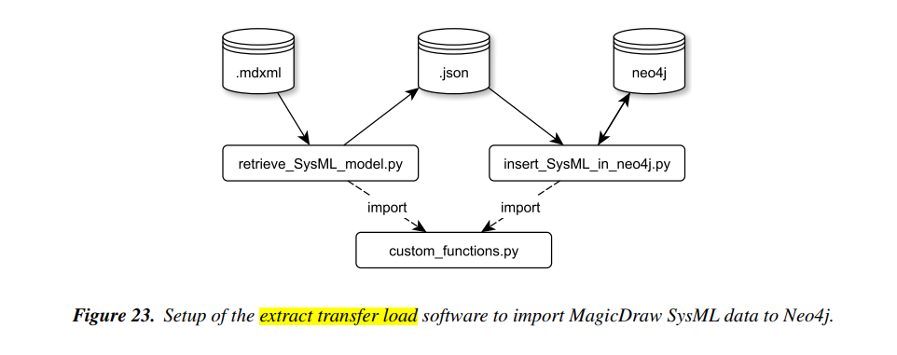

**Data Extraction Transfer and Load Process of Simulink Model to Neo4j**

**.slx**



**.json**



**.mdl**



neo4j

**generate**

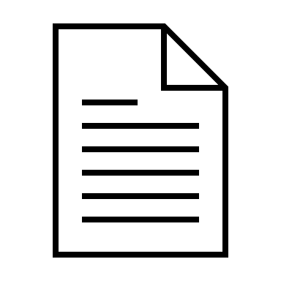

**Retrieve_Simulink_Model.pyy**

**Parser Simulink model**



**Insert_Simulink_Model_in_neo4j.pyy**

**Loader Simulink model**



**neo4j**



**Dashboard**

**import**



**Matlab_parser.m**